Interface Design Description (IDD) Certificate Provider

1. Interface Design Description Overview 3
2. Service Interfaces 3
   1. Interface 1 4
      1. Data Model 4
      2. Status and Error handling 5
      3. Interaction with consumers 5
3. Security 6
   1. Certificate 6
4. References 7
5. Revision history 8
   1. Amendments 8
   2. Quality Assurance 8

## Interface Design Description Overview

**Table 1 Pointers to SD documents**

|  |  |
| --- | --- |
| **Realised Service Description** | **Location** |
| CoPx request | SD_CertProd.pdf |

## Service Interfaces

## Interface 1

The service provides a response every time it is given a CoPx post request.

**Table 4 INTERFACE description**

|  |  |  |  |  |
| --- | --- | --- | --- | --- |
| **Interface name** | **Relative URL path** | **Method** | **Input** | **Output** |
| Certificate provider | CoPx request | POST | JSON | JSON |

A request example and and a response example are found next.

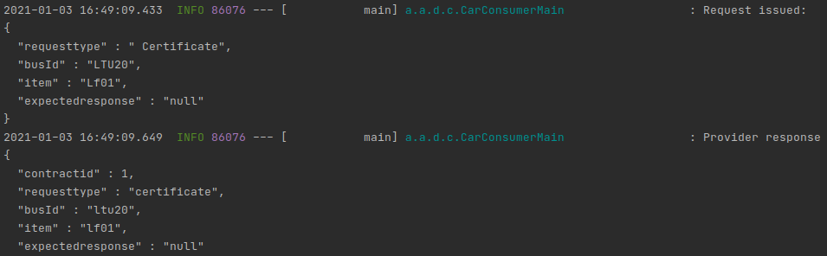

## Data Model

**Table 5 Data Object description**

|  |  |  |  |
| --- | --- | --- | --- |
| **Object Field** | **Description** | **Format/limitations** | **Required** |
| Requesttype | What is requested | String | Yes |
| BusId | Id of who is requesting | String | Yes |
| ItemId | Id of the item to register | String | Yes |
| Expectedresponse | If response is expected | String | No |

## Security

* The system creates the event for the Ongoing certificates to be created, without those the desired devices will not be able to start on the arrowhead systems.

## Certificate

* + In this particular application a dummy certificate is used, the system checks the presence of the item in the database rather than the validity of its credentials.

## Revision history

## Amendments

|  |  |  |  |  |
| --- | --- | --- | --- | --- |
| No. | Date | Version | Subject of Amendments | Author |
| 1 | 20-2-2015 | 1.0 | Revision of text | Michele Albano / Luis Ferreira |
| 2 | 30-09-2015 | 1.1 | Refinement of the structure | Michele Albano / Luis Ferreira |
| 3 | 2020-06-10 | 2.0 | Major update | Jerker Delsing |
| 4 | 2020-06-15 | 2.1 | More verbose help text | Emanuel Palm |
| 4 | 2020-08-17 | 4.2 | Cleaning and minor update | Jerker Delsing |

## Quality Assurance

|  |  |  |  |
| --- | --- | --- | --- |
| No. | Date | Version | Approved by |
| 1 |  |  |  |
| 2 |  |  |  |